Chapter 6: Decision Trees
Decision Trees are versatile Machine Learning algorithms capable of performing both classification and regression tasks, including multioutput tasks. They are powerful and can fit complex datasets. Decision Trees are also the fundamental components of Random Forests.
Training and Visualizing a Decision Tree
- Training: To train a Decision Tree classifier, you use Scikit-Learn's DecisionTreeClassifier. An important hyperparameter is max_depth, which controls the maximum depth of the tree.
- Visualization: You can visualize a trained Decision Tree by exporting a graph definition file (e.g., iris_tree.dot) using the export_graphviz() method. This .dot file can then be converted into image formats like PNG or PDF using the dot command-line tool from the graphviz package.
Making Predictions
- Process: To make a prediction for a new instance, you traverse the tree from the root node down to a leaf node. At each node, a question (based on a feature and a threshold) determines which child node to proceed to. Once a leaf node is reached, the predicted class for that node is returned.
- Node Attributes:
  - samples: Counts how many training instances apply to that node.
  - value: Indicates the count of training instances per class that apply to that node.
  - gini: Measures the node's impurity. A node is "pure" if all training instances it applies to belong to the same class, resulting in a Gini score of 0. The Gini impurity is calculated as
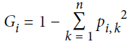
where $p_{i,k}$ is the ratio of class $k$ instances in the $i^{th}$ node.
- Tree Structure: Scikit-Learn uses the CART algorithm, which produces binary trees (nonleaf nodes always have two children for yes/no answers). Other algorithms, like ID3, can produce trees with more than two children per node.
- Data Preparation: Decision Trees require very little data preparation, specifically no feature scaling or centering is needed.
- Model Interpretation (White Box Model): Decision Trees are considered white box models because their decisions are intuitive and easy to interpret, providing simple classification rules. This contrasts with "black box" models like Random Forests or neural networks, where it's harder to explain why predictions were made.
Estimating Class Probabilities
- A Decision Tree can estimate the probability that an instance belongs to a particular class. It does this by traversing the tree to find the relevant leaf node and then returning the ratio of training instances of that class within that leaf node. The class with the highest probability is then predicted.
The CART Training Algorithm
- Greedy Approach: The CART (Classification And Regression Tree) algorithm, used by Scikit-Learn, is a greedy algorithm. It recursively splits the training set into two subsets by finding the feature ($k$) and threshold ($t_k$) pair that produces the purest subsets, weighted by their size.
- Cost Function for Classification: The algorithm aims to minimize the Gini impurity (or entropy) as defined by the cost function:
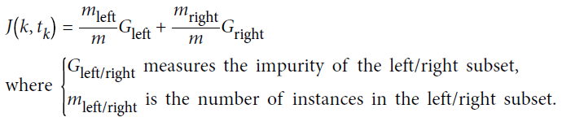
- Stopping Conditions: The recursion stops when it reaches the max_depth or if it cannot find a split that reduces impurity. Other hyperparameters like min_samples_split, min_samples_leaf, min_weight_fraction_leaf, and max_leaf_nodes also control stopping conditions.
- Optimal Solution: Finding the optimal tree is an NP-Complete problem, which is computationally intractable for even fairly small datasets (O(exp(m)) time complexity). Therefore, CART settles for a "reasonably good" solution rather than a guaranteed optimal one.
Computational Complexity
- Prediction: Traversing a Decision Tree for prediction is very fast, with a complexity of O(log2(m)), which is independent of the number of features. This is because Decision Trees are generally approximately balanced, requiring traversal through only a logarithmic number of nodes.
- Training: The training complexity is O(n × m log(m)). For small training sets (under a few thousand instances), setting presort=True can speed up training in Scikit-Learn, but it significantly slows down training for larger sets.
Gini Impurity or Entropy?
- Choice: By default, Gini impurity is used as the impurity measure, but entropy can be selected by setting the criterion hyperparameter to "entropy".
- Entropy Definition: The entropy of the $i^{th}$ node is defined as
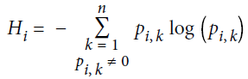
A set's entropy is zero if it contains instances of only one class.
- Comparison: Most of the time, Gini impurity and entropy lead to similar trees. Gini impurity is slightly faster to compute. When they differ, Gini impurity tends to isolate the most frequent class in its own branch, while entropy tends to produce slightly more balanced trees.
Regularization Hyperparameters
- Overfitting Tendency: Decision Trees are nonparametric models, meaning their number of parameters is not fixed before training. This allows them to adapt very closely to the training data, making them prone to overfitting.
- Regularization Methods: To avoid overfitting, you need to restrict the tree's freedom during training (regularization). This can be done by adjusting various hyperparameters:
  - max_depth: Reduces the maximum depth of the tree.
  - min_samples_split: Minimum number of samples a node must have to be split.
  - min_samples_leaf: Minimum number of samples a leaf node must have.
  - min_weight_fraction_leaf: Similar to min_samples_leaf, but as a fraction of total weighted instances.
  - max_leaf_nodes: Maximum number of leaf nodes.
  - max_features: Maximum number of features evaluated for splitting at each node.
  - Increasing min_* hyperparameters or reducing max_* hyperparameters will regularize the model.
- Pruning: Another regularization technique is pruning, where the tree is first grown without restrictions, and then unnecessary nodes are deleted if their purity improvement is not statistically significant (e.g., using a $\chi^2$ test).
Regression
- Decision Trees can also perform regression tasks using the DecisionTreeRegressor class.
- Prediction: Instead of predicting a class, a regression tree predicts a value in each node. This predicted value is typically the average target value of the training instances associated with that leaf node.
- CART Cost Function for Regression: The CART algorithm for regression aims to minimize the Mean Squared Error (MSE). The cost function is
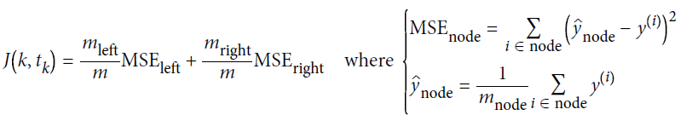
- Overfitting in Regression: Just like classification trees, regression trees are prone to overfitting without regularization. Regularization hyperparameters (e.g., min_samples_leaf) help create a more reasonable model.
Instability
- Orthogonal Decision Boundaries: Decision Trees inherently create orthogonal decision boundaries (splits perpendicular to axes), making them sensitive to training set rotation. Rotating the dataset can lead to unnecessarily convoluted decision boundaries and poor generalization. PCA can help mitigate this problem by reorienting the data.
- Sensitivity to Data Variations: Decision Trees are very sensitive to small variations in the training data. Even slight perturbations can lead to very different tree structures. Scikit-Learn's training algorithm is stochastic, meaning you might get different models on the same training data unless random_state is set.
- Solution: Random Forests address this instability by averaging predictions over many trees.

